[View Grades For Instructor]

Technical Document

Date: 13/Feb/2019

Version: Version 0.1

# Table of Contents

Table of Contents 1

[Task Name] 2

Description 2

1.1 Mockup screen: 2

1.2 Angular & Spring Models 3

1.3 Angular Component 3

1.4 Rest Services 3

1.5 Repository Functions 4

# 

# [Task Name]

Refer to: [Taiga URL]

## Description

View all student grade for instructor .

## Mockup screen:

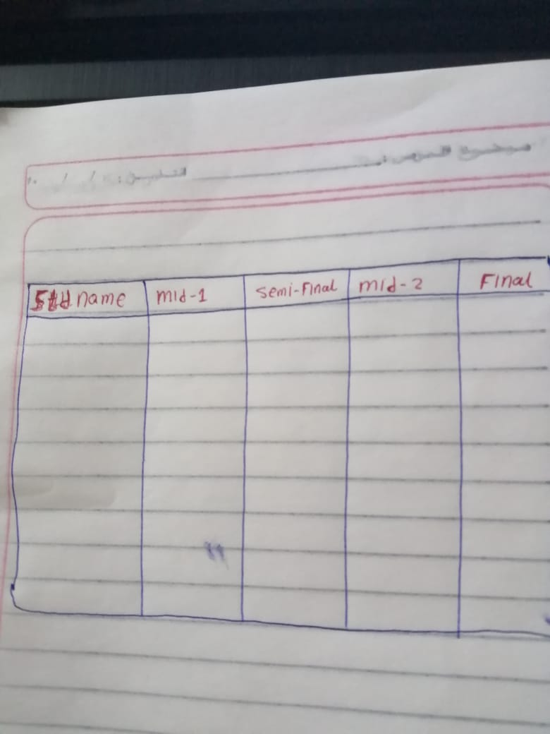

## Angular & Spring Models

|  |  |  |  |
| --- | --- | --- | --- |
| **New** | **Class Name** | StdDTO | |
| **Angular Path** | | app/modules/course/shared/data/std-dto.data.ts | |
| **Spring Path** | | model/course/StdDTO | |
| **Fields** | | | |
| **Attribute** | | **Angular Data Type** | **Spring Data Type** |
| fullName | | string | String |
| midTermOne | | number | int |
| semiFinal | | Number | int |
| midTermTwo | | Number | int |
| final | | Number | int |

|  |  |  |  |
| --- | --- | --- | --- |
| **New** | **Class Name** | | StdDTORM |
| **Spring Path** | | model/course/rm/StdDTORM | |
| **Fields** | | | |

## Angular Component

|  |  |  |
| --- | --- | --- |
| **New** | **Class Name** | ViewCourseGrades |
| **Path** | | app/modules/course/components/grade/view-grade.component.[ts/html] |

|  |  |  |
| --- | --- | --- |
| **New** | **Class Name** | CourseService |
| **Path** | | app/modules/course/shared/course.service.ts |
| **Function** | | getCourseGrades (data: CourseDTO) |

## Rest Services

|  |  |  |  |  |  |  |  |
| --- | --- | --- | --- | --- | --- | --- | --- |
| **New** | **Name** | | api/course/{courseID}/grade | | | **Method** | GET |
| **Controller** | | | CourseRes | | | **Function** | getCourseGrades courseID) |
| **REST Parameter** | | | | | | | |
| **Attribute** | | **Parameter Type** | | **Data Type** | **Description** | | |
| courseID | | Path Parameter | | int |  | | |

## Repository Functions

|  |  |  |  |  |
| --- | --- | --- | --- | --- |
| **New** | **Class Name** | GradeRep | **Type** | select SQL |
| **Function** | | findCourseGrades (int courseID ) | | |
| **Query** | | | | |
| Select std.first_name , std.last_name,std.id ,cor.mid_1_grd,cor.semi_final_grd,cor.mid_2_grd,cor.final_grd  from auth_user std  join course_std cor  on (std.id = cor.std_id)  where cor_id = ? | | | | |